**Forced Overtime**

An employee can be forced to work an overtime slot up to 4 hours if no employee could be found to work it.

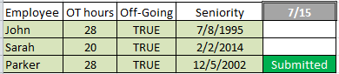

On 7/13 the submission/withdrawal for overtime blocks on 7/15 are locked.

The decision process of who will be awarded the overtime of 7/15 works like the following:

1. Who wants to work the overtime? **Parker**
2. Out of these names, who is on the Off-going shift? **Parker**
3. Out of these names, who has the least overtime hours? **Parker**
4. Out of these names, who has seniority? **Parker**

Parker is awarded the overtime and now has 36 OT hours.

On 7/15 the supervisor has a call-off that needs to be filled. He follows the procedure for call-offs and no one is willing to work the overtime.

*Sarah has now “refused” to work the known overtime that she could have submitted for as well as the unknown overtime the supervisor asked her to work on the 15th. This does not mean that she will be charged another 8 hours of OT. She has already been charged with the OT for this shift therefore she cannot accumulate more.*

The supervisor now needs to force the most eligible employee to work the overtime. A list is generated of the most eligible employees for the first 4 then the last 4. For an employee to be considered most eligible in this situation they will be tested on the following parameters in this order:

1. Who is on the Off-going shift? **John, Sarah, and Parker**
2. Out of these names, who hasn’t already been forced? **John and Sarah**
3. Out of these names, who has least seniority? **Sarah**

Sarah’s name is at the top of the list and must be approached and forced to work the overtime. If she refuses to work the overtime she will lose one of her 6 refusals and the supervisor will move on to the next employee on the list.

If necessary, the process is then repeated with oncoming employees to see who should work the last 4.

***Refusing Forced Overtime***

An employee can refuse to work forced overtime up to six times in a calendar year.

After 12 months from the time the refusal was made they will get the refusal back.

They can also earn a refusal if they are mandated to work overtime more than 6 times.

This earned refusal cannot be used within 10 days of it being granted and must be used within 12 months of when it was granted.

**Working hour limits**

An employee can only work a maximum of 16 hours within a 24 hour period.

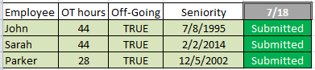

On 7/16 the submission/withdrawal for overtime blocks on 7/18 are locked.

The decision process of who will be awarded the overtime of 7/18 works like the following:

1. Who wants to work the overtime? **John, Parker, and Sarah**
2. Out of these names, who is on the Off-going shift? **John, Parker, and Sarah**
3. Out of these names, who has the least overtime hours? **Parker**
4. Out of these names, who has seniority? **Parker**

Parker is awarded the overtime and now has 36 OT hours.

The shift right after this one also needs overtime for the same job code. All three employees also applied for this one.

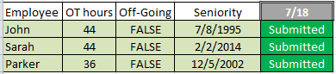

Parker would not actually show up in this list anymore because he is already scheduled to work 16 hours within 24 hours.

John would get the overtime for this shift because of his seniority.

**Submitting for First 4 or Last 4 OT Blocks**

Employees who submit for the full 8 hours of overtime are automatically more eligible than employees who submit for only the first/last 4.

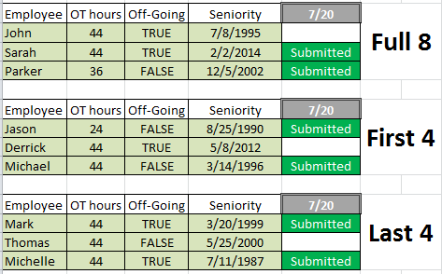

For this scenario there are 3 overtime slots available for this job code and shift number. The decision process always starts with the employees who are willing to work the full 8. If there are any slots left it will split them and start filling with the other 2 OT blocks employees have submitted.

On 7/18 the submission/withdrawal for overtime blocks on 7/20 are locked.

The decision process of who will be awarded the overtime of 7/20 works like the following:

1. Who wants to work the overtime? **Sarah and Parker**
2. Out of these names, who is on the Off-going shift? **Sarah**
3. Out of these names, who has the least overtime hours? **Sarah**
4. Out of these names, who has seniority? **Sarah**

Sarah is awarded the first overtime slot. Parker will be awarded the second as he is the only other employee who is willing to work the full 8. The remaining overtime slot will be split and then filled by the first/last 4 OT blocks. The first 4 OT block will be awarded to Jason and the last 4 OT block will be awarded to Michelle.

A supervisor can generate an OT need that is only for the first/last 4. At which point the need will be filled by the corresponding OT block submissions.

An employee can still submit for all three OT blocks but the full 8 will be prioritized.